**Can-Sat Rocket proposal**

**Description:**

**Rocket elements:**

* **Body**
* **Chemicals**
* **Parachuting system**
* **Control & ignition circuit**

**Body elements**

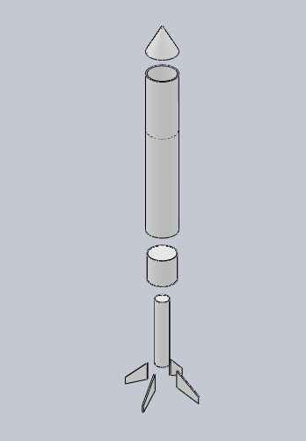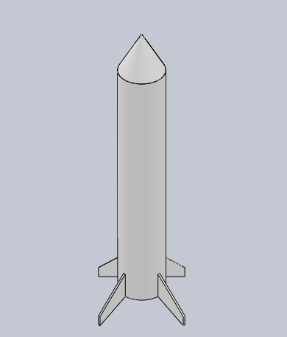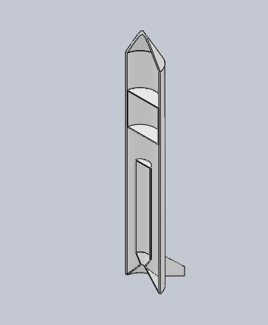It will be a 1 meter rocket from PVC pipes with diameter 12 cm, containing the fuel chamber and the can-sat with its parachute.

**Materials:**

* **1m PVC pipe diameter 12 cm**
* **40 cm PVC pipe 5 cm diameter**
* **Nose cone plastic or PVC**
* **Fins (wood preferred)**
* **Nozzle PVC**
* **Epoxy or PVC glue**

**Chemicals and requirements**

We are going to use nitrates with **sorbitol** which is available, the chemical reaction is described by this equation:  
5O2 + 4KNO3 + 2C6H4O6 _ 12CO2 + 4H2O + 2N2 + 2K2CO3

**Materials:**

1KG KNO3 (potassium nitrate) *5 for 5 trials

0.5KG sorbitol (sugar) *5 for five trials

**Parachuting system**

The parachuting system will contain two parachutes one for the can-sat and the other is for the rocket, the parachute will be controlled from our micro-controller wirelessly.

**Materials:**

* **Servo motor 360 for controlling**
* **Driller**
* **Scotch**

**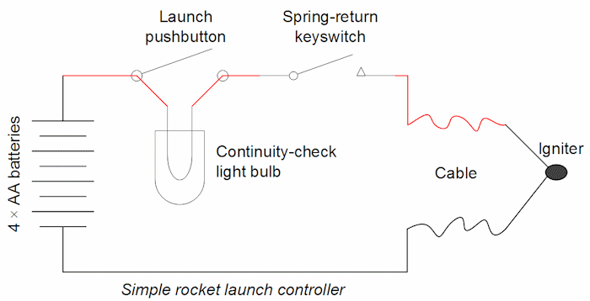  
  
 Ignition**It’s a basic launch system controller .

Material :  
Battery 12 V   
Cable 10 m  
Pyrogen wire  
Push button